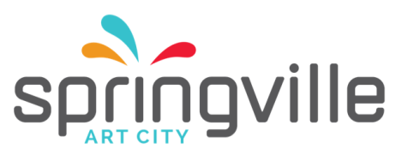

Museum Event Host l
Job Description
(last updated: 10/2018)

Department: | Museum
Position Reports to: | Event Host ll
Pay Grade: | 2
Employment Type: | Part-time
Exempt/Nonexempt: | Non-exempt
Description: | Under the direction of the Event Host II, the Host represents the Springville Museum of Art (SMA) in providing gracious and attentive customer service to rental parties and their guests. The Host is responsible for following the direction of the Head Host in ensuring SMA policies are followed during events, that the facility is clean, and that the artwork, building and equipment are protected from damage and loss. Must be available to work evenings and occasional daytime hours, between 5-25 hrs. per week.
Duties: | Represent the SMA and City of Springville in a positive manner  Provide superior customer service to rental parties, vendors, and their guests  Follow the direction of the Head Host  Coordinate with the Head Host to ensure the rental party, vendors,  and guests conform to SMA policies  Assist in overseeing the security of the artwork, building and equipment  Clean the rental facility areas before, during and after events  Graciously direct rental party concerns to the Head Host  Handle and move art under the direction of the Head Host  Demonstrate professionalism and maturity  Work with co-workers on set-up & clean up
 | All other duties as assigned.
Qualifications: | Must be a minimum of 18 years of age and a graduate of high school or equivalent program. Must have at least one year of experience in customer service.  Skills, Knowledge & Abilities:  Demonstrated ability to provide gracious and attentive customer service is paramount. Strong interpersonal skills, work ethic, initiative, and professional presentation are crucial. Must be able to understand and follow oral and written instructions. Must be able to cultivate and maintain effective working relationships with co-workers, supervisors, rental parties, vendors and guests.
Physical Demands: | Performs duties for cleaning, set up/take down and moving artwork, that may include physical effort such as lifting, bending stooping, walking, and prolonged sitting or standing. Occasionally may lift materials weighing as much as 40 pounds.

